Survey System User Manual

**Installation**

Create a new database and run the included createstatement.sql queries to set it up. Then create an account with read and write permissions to be used by the survey system.

Configure the following files:

* connect.ini:
  + username: the username used for accessing the database.
  + password: the password paired with the username for accessing the database.
  + dname: the name of the MqSQL database.
* emailscript.ini:
  + subject: the subject line for the initial email.
  + email: the body text for the initial email.
  + remindersubject: the subject line for the reminder email.
  + reminderemail: the body text for the reminder email.
  + NOTE: the software will automatically replace the following:
    - [Company]: replaced with name of the company.
    - [Date]: replaced with survey end date (‘Jan 1st’ format).
    - [URL]: replaced with link to survey page.
* login.ini:
  + username: the username used to log into the admin page.
  + password: the password used to log into the admin page.

Copy the following files into the root folder of your web server:

* admincompany.php
* admindepartment.php
* adminparticipant.php
* adminquestion.php
* Adminsurvey.php
* connect.ini
* Createsurvey.php
* emailscript.ini
* login.php
* login.ini

Copy the following files into the public_html folder of your web server.

* admin.php
* createparticipant.php
* generatereport.php
* querydatabase.php
* reminderemail.php
* submitsurvey.php
* survey.php

The survey system can then be accessed from: [Domain Name]/admin.php

**Configuring the Question Pool**

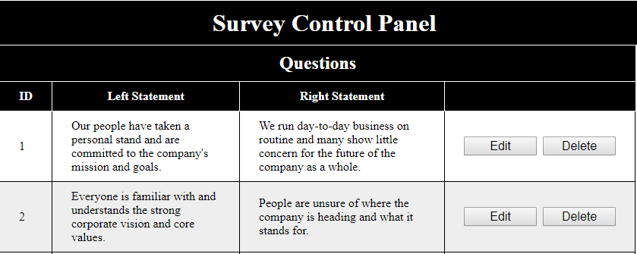

Open the admin page and go to the Manage Questions tab. At the bottom of the page, you’ll see a section for entering in new questions:



Enter in the question number, left statement, and right statement. Then click the ‘Add Question’ button to create a new entry for the question in the database. Repeat this to add as many questions as you’d like.



If you want to edit a question, click the ‘Edit’ button next to the question. The left and right statement fields will become editable text boxes. Make the necessary changes and then click the ‘Save’ button to commit the change to the database. If you want to back out without saving your changes, click the ‘Cancel’ button instead.

If you want to remove a question, click the ‘Delete’ button next to the question and confirm your choice in the popup window. Beware, however, as this will remove the question from any surveys that are using it. Responses tied to the question will also be deleted.

**Adding a Company**

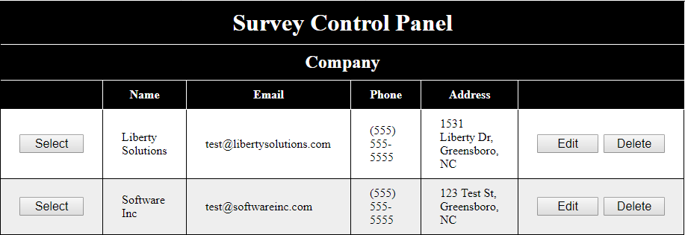

Before you can create a survey, you’ll need to add the company which will be surveyed. Open the admin page and go to the Manage Surveys tab. Here, you’ll see a section for entering in a new company:



Enter the company name, email address, phone number, and address. Then click the ‘Add Company’ button to create an entry for the company in the database.

**Creating a Survey**

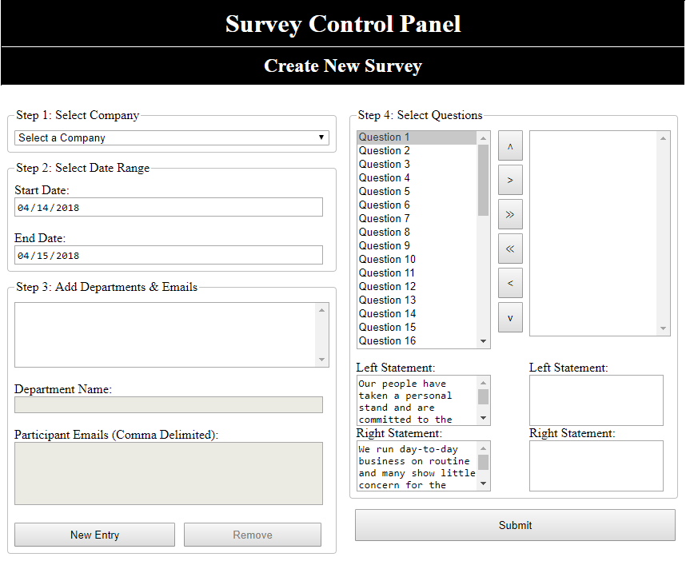

Once the question pool has been configured and at least one company has been added, go to the ‘Create New Survey’ tab. Here, you’ll see a set of fields used to configure the new survey. Follow the below steps to create the survey:

1. Select a company from the drop down list.
2. Configure the start and end date for the survey.
3. Add the departments and employee emails to be used by the survey:
   1. Click the ‘New Entry’ button.
   2. Type in the Department Name.
   3. Type (or copy in) a comma delimited list of employee emails for that department.
   4. Click the ‘Add Entry’ button.
   5. Repeat steps a through d for each department to be included in the survey.
4. Select the questions that will be used in the survey.
   1. The first list contains the list of available question (the question pool).
   2. The second list contains the list of questions to be included in the survey.
   3. Click the right arrow button to move the selected question in the first list over to the second list.
      1. Click the double right arrow button to move all questions in the first list over to the second list.
   4. Click the left arrow button to move the selected question in the second list back to the first list.
      1. Click the double left arrow button to move the selected question in the second list back to the first list.
   5. Click the up and down buttons to reorder the question in the second list.
5. Once the survey has been configured, click the ‘Submit’ button. The necessary entries will be added to the database and emails will be sent out to the participating employees in each specified department.

**Managing an Active Survey**

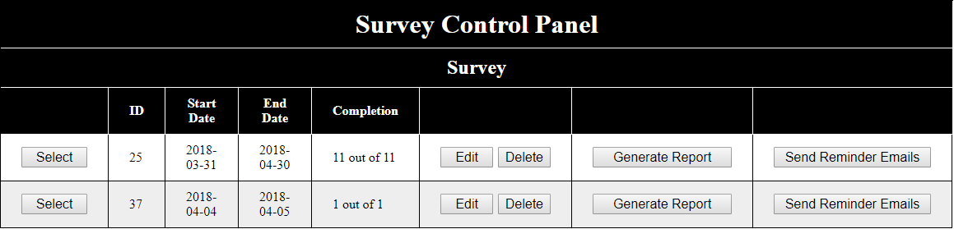

Open the admin page and go to the Manage Surveys tab. Click the ‘Select’ button for the company that has the survey you wish to manage. This will take you to the Survey section, containing a list of surveys (past and present) for the company. Clicking the ‘Select’ button for the desired survey will take you to the Department section, showing the list of departments participating in the survey. Clicking the ‘Select’ button for one of the departments will take you to the Participants section, showing the participants for that department. Here’s what you can do in each section:

* Survey Section:
  + Edit the start and end date for a survey.
  + Delete a survey.
    - NOTE: All departments, participants, and responses tied to the survey will also be deleted.
  + Generate a report for the survey (see next section)
  + Send reminder emails to all survey participants who have not yet submitted.
* Department Section:
  + Edit the name of a department.
  + Delete a department.
    - NOTE: All participants and responses tied to the department will also be deleted.
  + Send reminder emails to all participants in the department who have not yet submitted.
* Participant Section:
  + Add a new participant (email will be sent out).
  + Edit the email of a participant.
  + Delete a participant
    - NOTE: Participants who have submitted cannot be deleted. This is to maintain the integrity of the survey, since survey responses are recorded separately from the participants.
  + Move participant to another department.
    - NOTE: Participants who have submitted cannot be moved.
  + Send a reminder email to an individual participant who has not submitted.

**Generate Reports**

To generate a report for a survey, go to the survey section for the company hosting the survey and click the ‘Generate Report’ button. This will generate an Excel (.xlsx) file and offer it to you as a download. Open the file to view the survey responses both by department and for the survey as a whole. Charts are provided to make the results easier to understand.